- Remove character &
Replace with the Mario character in the Nintendo logo
- Can you use this font & colour for wiichip-xtreme,
Using the ring around the Nintendo & the Mario character

- Can you use this font Nintendo & colour for wiichip-xtreme,
Using the ring around the Nintendo & the Mario character
- Change the blue background to the same green on shop home page....
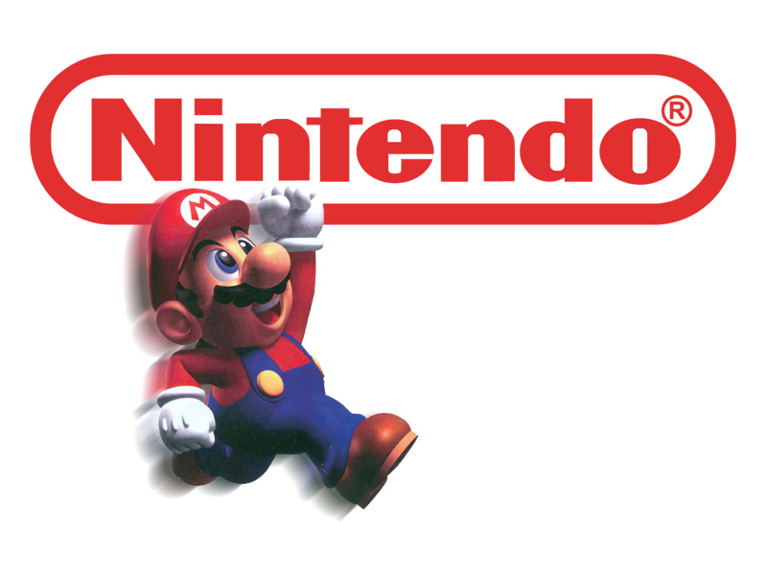
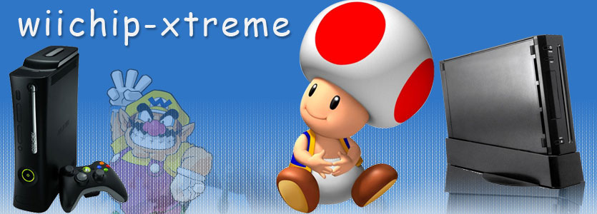
Remove character &
Replace with the Mario character in the Nintendo logo

